1. “Daily Energy Drinks TRIPLE Your Risk of Heart Palpitations!”
Given:
- Among 1,000 non‐drinkers: 10 develop palpitations.
- Among 1,000 daily drinkers: 30 develop palpitations.

(a) How many extra people develop palpitations?
- Non‐drinkers: 10 cases per 1,000 (1.0%)
- Daily drinkers: 30 cases per 1,000 (3.0%)
- Extra cases = 30 − 10 = 20 more palpitations per 1,000 people.

(b) Relative risk (RR)
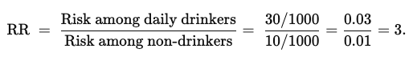
So the relative risk is 3—i.e., “triple.”

(c) Rewriting the headline in absolute terms
- Baseline risk = 1.0%
- New risk = 3.0%
- “Triples your risk” translates to an increase of 2 percentage points (from 1% to 3%). In terms of frequency, that’s 20 extra cases per 1,000 people. This absolute‐risk framing is less sensational than simply saying “triples your risk.”

2. “Study: Owning a Cat Raises Breast Cancer Risk by 15%”
Given:
- Baseline (non‐cat owners): 200 out of 10,000 develop breast cancer (2%).
- Cat owners: 15% higher risk than baseline.

(a) Expected number among cat owners
- Baseline risk = 2%
- 15% increase → new risk = 2% × (1 + 0.15) = 2.0% × 1.15 = 2.3%.
- Out of 10,000 cat owners: 2.3% of 10,000 → 230 cases.

(b) “Extra cases per 10,000 people”
- Baseline group: 200 cases.
- Cat‐owner group: 230 cases.
- Extra = 230 − 200 = 30 more cases per 10,000, i.e. 0.3% in absolute terms.

(c) Odds ratio
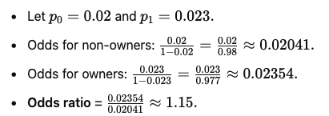
This is close to the 15% relative‐risk figure but not exactly the same number—an illustration that OR ≈ RR when the baseline risk is small.

3. “Processed Meat Linked to 20% Higher Bowel Cancer Risk”
Given:
- Baseline risk: 6 in 100 (6%).

(a) New probability if 20% higher

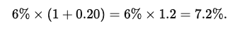

(b) Extra cases per 1,000
- Baseline: 6% of 1,000 → 60 cases.
- New group: 7.2% of 1,000 → 72 cases.
- Extra = 72 − 60 = 12 per 1,000.

(c) Headline framing
- Relative‐risk framing: “20% higher” or “20% increase.”
- Absolute‐risk framing: “An additional 1 to 2 cases for every 100 people.”
The second version communicates a smaller‐sounding increase, even though both statements are correct.

4. “University Education Increases Risk of Brain Tumors by 19%”
Given:
- Baseline: 5 in 10,000 people (0.05%) over ten years.

(a) New expected rate
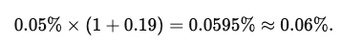
Out of 10,000 people: 6 cases instead of 5.

(b) Alternative headline
- Instead of “greatly ups your tumor risk,” one might say:
“1 extra case per 10,000 people over a decade.”

(c) Interpretation
- Even a “significant” 19% relative jump corresponds to just 1 more tumor per 10,000 people. The small baseline rate makes the absolute change minor.

5. (Optional) “Twice as Likely to Catch the Flu if You Have Pets at Home”
Given:
- 2,000 non‐pet households: 100 had flu → 100/2000 = 5%.
- 2,000 pet‐owning households: 200 had flu → 200/2000 = 10%.

(a) Relative risk
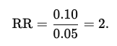
So pet‐owning households are twice as likely to report flu.

(b) Odds ratio
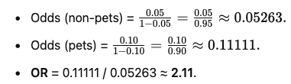
The odds ratio (2.11) is slightly higher than the relative risk (2.0), a typical difference when baseline risk is not extremely small.

(c) Absolute‐risk framing
- Non‐pet households: 100 out of 2,000.
- Pet households: 200 out of 2,000.
- In absolute terms, “an additional 100 households (per 2,000) had flu” is less dramatic than “twice as likely.”

